KidzCoding Hour of Code - Eating Simulator

Activity:

In this activity you will learn how to create a food eating game.

Learning Objectives:

* Learn how to manipulate the size of sprites in scratch
* Learn how to use forever loops
* Learn how to effectively use the “hide” and “show” functions within scratch for effective game development

Materials:

* Completed project: <https://scratch.mit.edu/projects/879300048>
* Starter: <https://scratch.mit.edu/projects/879888297>

Coding Time!

Step one: The creating variable and sprites

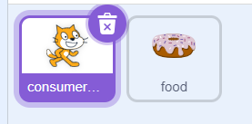

* **Choose whichever sprite you want to eat the food**
* **Pick out any food you want from scratch’s provided sprites**
* **Create a variable called “points”**

Step two: Cloning

* 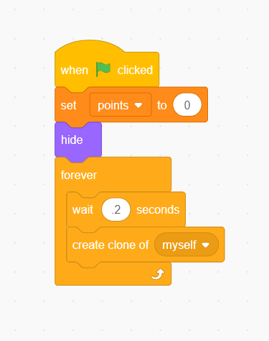**With the food sprite selected, add a “when started” block and right below that make it so that the “points” variable is set to zero**
* **Make it so that the food sprite upon the start of the program hides itself**
* **In a forever loop, make it so that the sprite waits for a fraction of a second before creating a clone of itself**

Step three: designing the clones

* 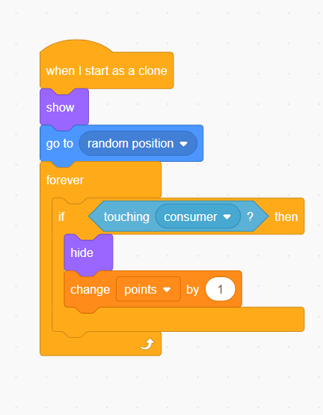**Firstly, begin by adding the “when I start as a clone” block**
* **Then, make the clone show itself and go to a random location**
* **Next, in a forever loop, make it so that if the food is touching the food consumer sprite, change the variable “points” by one and hide**

Step four: designing the consumer

* 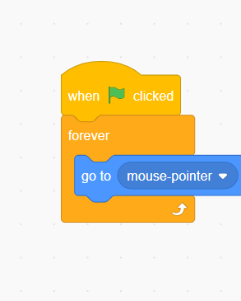**Firstly, begin by adding the when started block**
* **Below the when started block, add a forever loop, and inside the forever loop add a “go to mouse cursor” block**

Step five: Adding effects

* 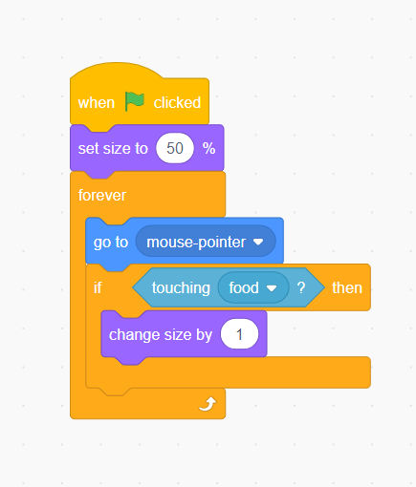**By default, the sprites in scratch are pretty big, which makes this game too easy for the average user. To change this, you can use the “set size” and “change size” blocks.**
* **To do this, you can select the consumer sprite and add a “change size” block**
* **I recommend you make it at least twice as small as it is normally**
* **You can do the same thing to the food sprite so its harder to pick up**
* **Then, if you want to get even more fancy you can make it so that the consumer sprite gains a percentage of mass with each food consumed**

Congratulations, you have just completed an Hour of Code!